Thyroid Disease Detection

*Wireframe documentation*

*Developed by-*

ADITYA MARNE

SOHAM JAGTAP

ADNAN SHEIKH

SUFIYAN SHAIKH

# Homepage

User can able to view the following webpage once entering into web application

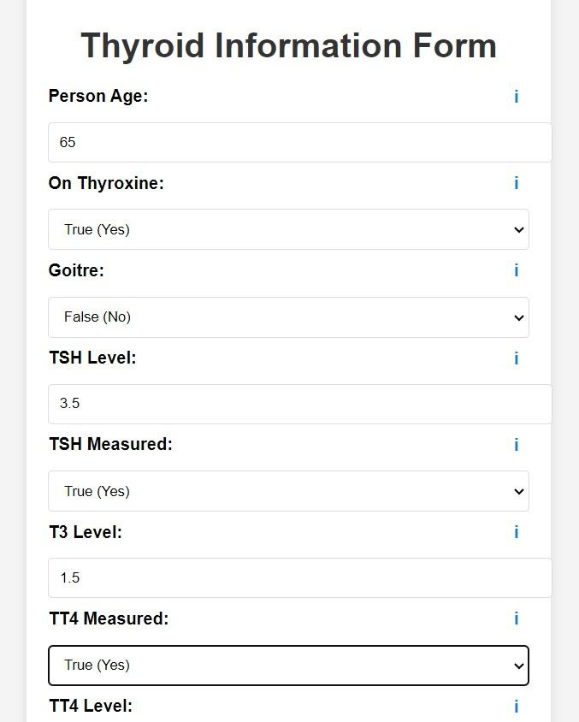

After filling the above information use able to see:



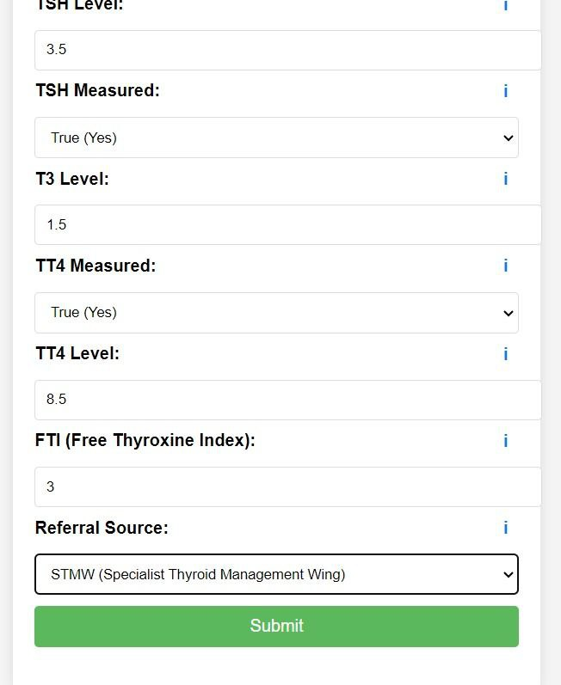

# Results

After clicking on the Submit button, results will be displayed below the button

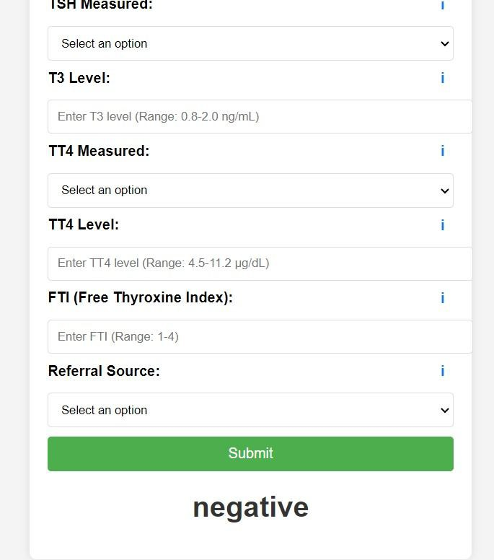

# Database

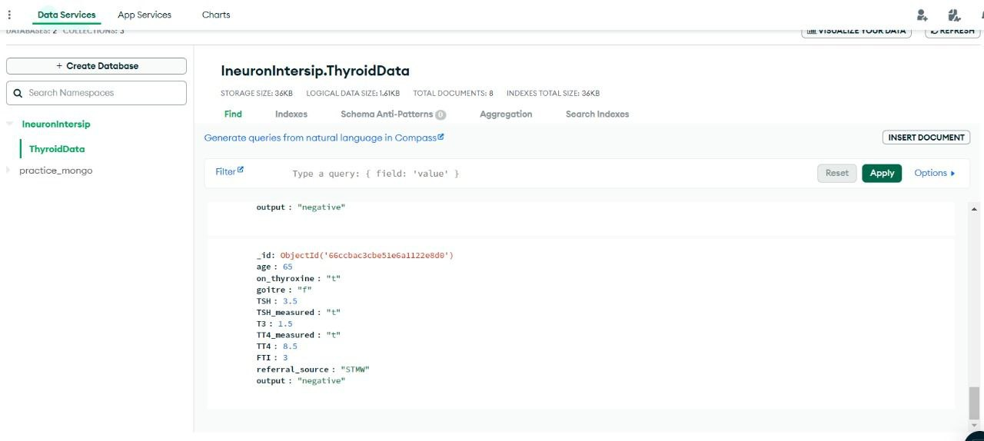

The information provided by the user, will be stored in the database once the user clicks on the submit button